Extension of Time and Loss & Expense Narrative #: Contract Instruction 06 Vobster stones

A. Introduction
- This narrative sets out the Contractor’s (ULS) entitlement arising out of changes to the design of part of the external facades instructed by the Employer (THDM) under Change Request 07a dated 2 June 2020, and Contract Instruction 06 dated 6 October 2020.
- These instructions were Changes under clause 5.1 of the Contract and constituted a Relevant Event under clause 2.26.1 and a Relevant Matter under clause 4.21.1 respectively.

B. Summary
- THDM changed the design of part of the external façades (a) from a glass reinforced concrete cladding to Vobster stone cladding panels, requiring to larger stones/panels, and (b) for aesthetic reasons, to require banding panels to match the joints, requiring the panels to be all different sizes and a more time-consuming installation process.
- These changes caused significant delays to the production, delivery and installation of the cladding panels.

C. Position under the Contract
- ULS’ contract works included the design, supply and installation of the façade. The Employers Requirements Volume 2; M Façade; M02 Specification; Stage 3 Specification for the Façade specified two different façade systems: (1) glass reinforced concrete (GRC) cladding, and (2) aluminium rainscreen cladding.
- This claim relates to the GRC cladding.
- Elevation drawings were included within the Employer’s Requirements Volume 2a; D04; Architect; L(00) ELEV detailing the areas requiring GRC cladding.
- The GRC façade works were priced and detailed within Contract Document Vol 1, ULS Contract Sum Analysis, element 7 ‘External Walls’.

D. Change
- THDM and their architect PTE had been in communication with Taylor Maxwell, a façade product supplier, in early 2020 regarding alternatives to the GRC façade. THDM had received a quotation for the Vobster stone directly from Taylor Maxwell in April 2020, indicating advanced discussions in respect of the proposal, in the absence of ULS.
CR 07
- Following early engagement between THDM and Taylor Maxwell, on 5 May 2020, ULS received Change Request 07 (CR 07) from the Employer’s Agent (EA), asking it to contact Taylor Maxwell and then provide time, cost, design and quality impacts for a proposed change of the GRC cladding to one of 3 options: (1) Argeton terracotta, (2) Vobster stone, and (3) Chatsworth GRC.
- Following receipt of CR 07, on 6 May 2020 ULS contacted Taylor Maxwell, as requested, to gather information on the 3 GRC alternatives which Taylor Maxwell had already discussed with THDM.
- Taylor Maxwell responded to ULS on 13 May 2020 providing initial details of the discussions it had had with THDM and PTE, highlighting the three options that had been tabled and a brief summary of each.
[Do we have correspondence from THDM or PTE confirming the selection of Vobster? (Which we then inform TM of per para 13 below)]
- On 29 May 2020, ULS informed Taylor Maxwell that THDM had decided to go with the Vobster option as the alternative to the GRC façade.
CR 07a
- Following further conversations between THDM and Taylor Maxwell, on 2 June 2020, ULS received CR 07a from the Employers Agent. The key change from CR07, was that in CR 07a the GRC alternative option specified was ‘Vobster’. Further specifics were provided, such as colour code ‘RAL 3012’.

- CR 07a detailed the following:
“Please provide the time, cost, design and quality impacts from the following proposed change: Replacement of the GRC cladding to:
Vobster recon Stone System in accordance with the below table.
”
- CR 07a included a set of elevation drawings, ‘CR 7a drawings Welbourne Combined Elevs To UL 2020-06-02’. The drawings included a marked up colour coded ‘Material Key', detailed below:
- 03 - Insulated – highlighted in red
- 04a - GRC vertical rainscreen feature panel - highlighted in purple
- 04b - GRC vertical rainscreen feature panel - highlighted in yellow
- 04c - GRC horizontal spandrel panel – highlighted in orange.
- The ‘CR 7a drawings Welbourne Combined Elevs To UL 2020-06-02’ drawings were marked up according to the colour code above (extracted below). Materials 04a, 04b and 04c were to be replaced by the Vobster stone. Notably the design did not include any specific parameters or constraints, such as the size or layout of the stones.
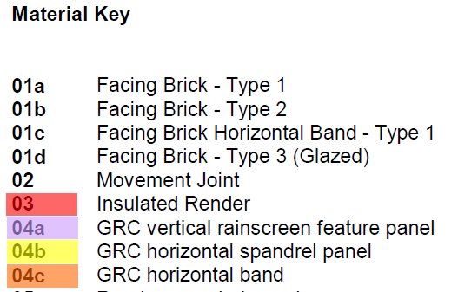
CR 07a Quotation
- On 7 September 2020, ULS issued a ‘table confirming the sequence and timings’ on which its quotation for CR 07a would be based upon. The dates included were indicative and to demonstrate durations only, subject to instruction. These durations had been pre-agreed by Taylor Maxwell and sequenced to ULS’ programme of works. Extracted as follows:
“Further to our meeting last week. I have now have the confirmation on durations for the design, manufacture & delivery for the GRC alternative, ‘Vobster’ by Taylor Maxwell.
So please see below a simple table confirming the sequence and timings to when items will first be delivered to Site next year. I have based this table on the client confirming the choice of material selection to enable UL to start the detail design.”
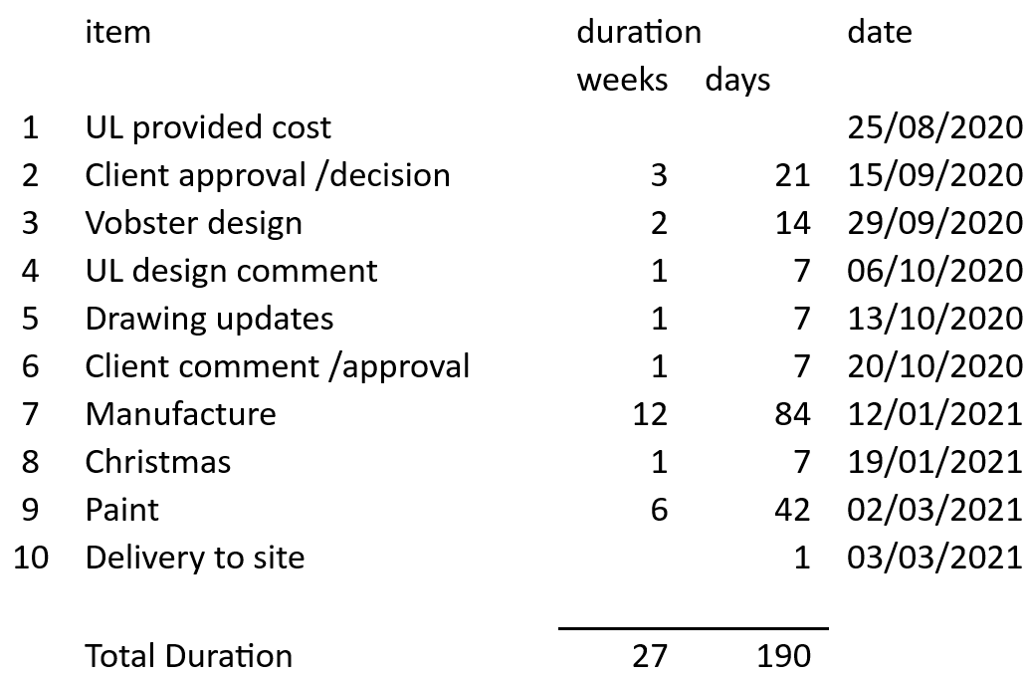
- As requested by the EA, on 10 September 2020, ULS provided their quotation for CR07a on an ‘open-book’ basis (“CR 07a Quotation”).
- Overall, ULS proposed a proposed cost-saving of £43,093.00. This price was based on the drawings provided under CR 07a and the quotations received by Taylor Maxwell, the nominated supplier, for the specified Vobster stone and the durations set out in ULS’ email to the EA on 7 September 2020.
- ULS’ CR 07a quotation is at Appendix X.
- Copies of all supplier and sub-contractor quotations were provided to the EA, which demonstrated the basis of the price. These showed that the panels were to be 1m sections of stone.
- The following quotations from Taylor Maxwell were provided, dated 18 September 2020 [How do these dates align? The quotations are dated after we said we provided them/ our quote]:
  - ‘QLH_003628_001 - UNITED0052’ – this quotation was for the ‘04a – GRC vertical rainscreen feature panel’ Vobster stone alternative, highlighted on ‘CR 7a drawings Welbourne Combined Elevs To UL 2020-06-02’ in purple. The total price was for £173,926.99, including 7nr deliveries.
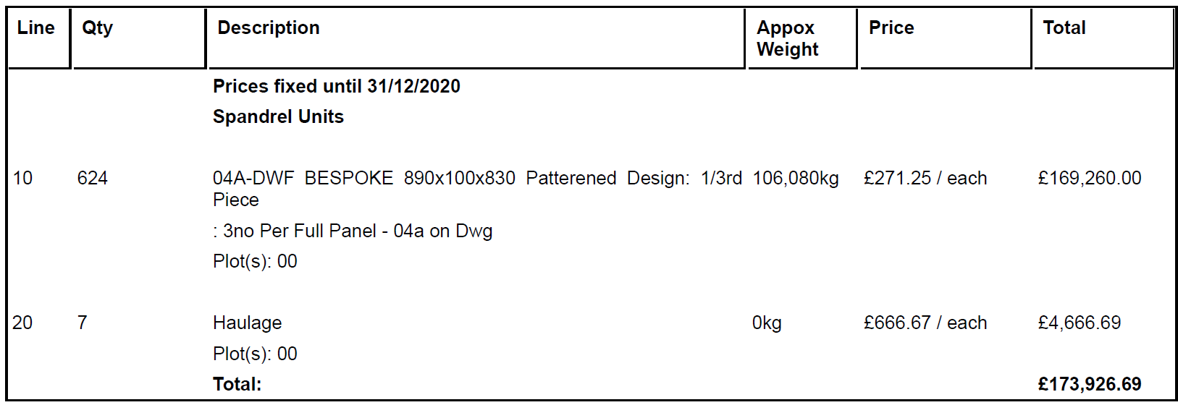
  - ‘QLH_003629_001 - UNITED0052’ – this quotation was for the ‘04b - GRC horizontal spandrel panel’ Vobster stone alternative, highlighted on ‘CR 7a drawings Welbourne Combined Elevs To UL 2020-06-02’ in yellow. The total price was for £94,568.48, including 4nr deliveries.
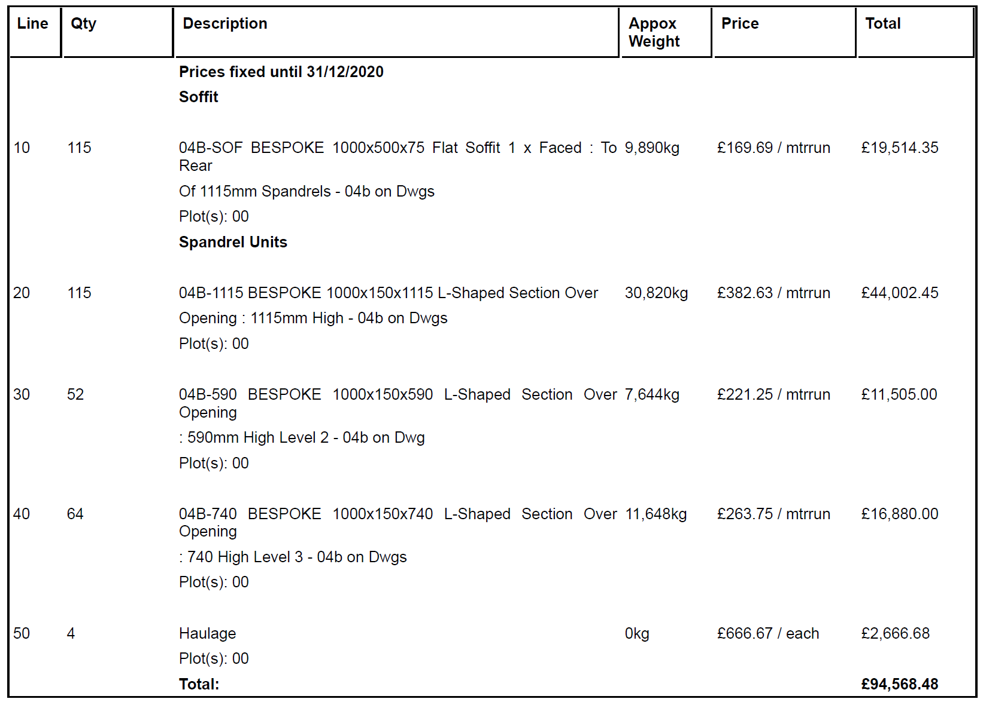
  - ‘QLH_003630_001 - UNITED0052’ – this quotation was for the ‘04c - GRC horizontal band’ Vobster stone alternative, highlighted on ‘CR 7a drawings Welbourne Combined Elevs To UL 2020-06-02’ in orange. The total price was for £74,059.18, including 4nr deliveries.
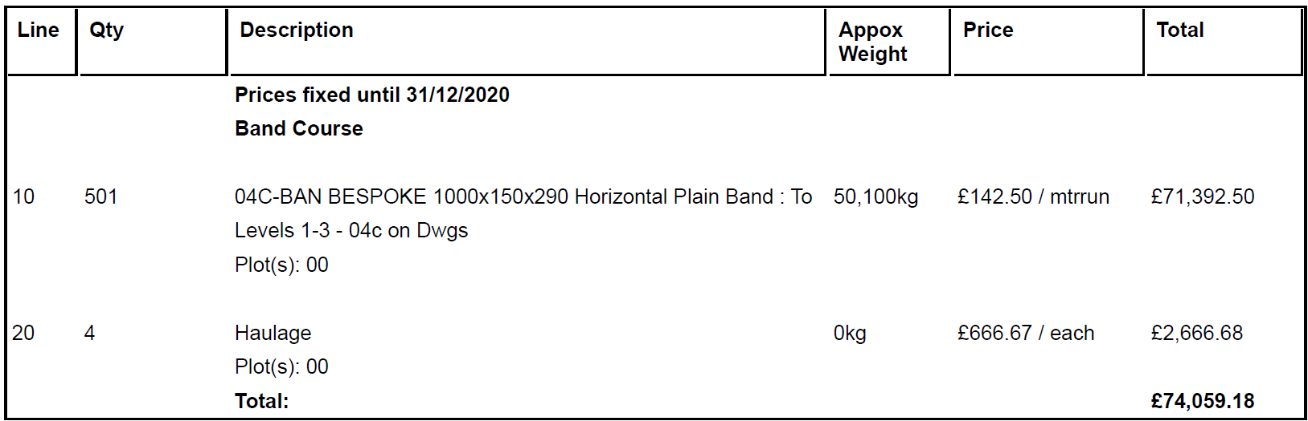
  - The total sum of the Taylor Maxwell quotations for the design under CR7a was £342,554.65, requiring 15 deliveries to site.
- The basis of ULS’ price and the quotations received by Taylor Maxwell were discussed with THDM/ the EA. In particular: [I have not seen these emails. Where are they?]
  - 25 August 2020 – the EA emailed ULS providing a copy of the quotation they had received directly from Taylor Maxwell in April 2020 for £309,088.02, querying why there had been an increase from this price in the CR 07a Quotation.
  - 15 September 2020 – ULS emailed Taylor Maxwell advising that they were communicating with Vobster on the cost increase. ULS queried whether the paint finish, which had changed from white to ‘Kiem 9183’, had caused the cost increase.
  - 16 September 2020 – Taylor Maxwell provide clarification on the cost increases and a breakdown within the email.
  - 18 September 2020 – Taylor Maxwell reiterated that the stone has been priced based on 1m sections.
  - 18 September 2020 – ULS forwarded Taylor Maxwell’s email to THDM, EA and the client management team (CMT):
“Further to out meeting yesterday, please see an email received from Taylor Maxwell about the sizing of the panels. Hopefully, this answer your questions about the sizing. With regards to a meeting, if you still require this, after the clarification below, we cannot confirm a date until next week as the correct person from Vobster, whom would need to attend any meeting is on annual leave this week, so we cannot confirm a date yet.”
  - 21 September 2020 – THDM responded to ULS expressing concerns that Taylor Maxwell was unclear on the number of joints that would be required. THDM suggested a meeting be held with ULS, CMT, Taylor Maxwell and Vobster (see further below). THDM’s email showed that it was aware that the design had developed beyond the original scope in CR 07a:
“My concern at this point is AR do not have any certainty around the number of joints that would be likely to occur on the Welbourne project as a result of the required weights etc. While I appreciate the note below advises that the lengths can be flexible AR requires some visibility around the number of joints required to a worst case area (I believe ground floor) and a standard area (side residential panel?). This small sample area would then provide comfort to the number of joints across the whole façade.
The ideal would be to hold a simple session with the appropriate sub-contractor and PTE to talk it through. I expect once this understood the progressing of the change will be quicker anyway.
As I am sure you an [sic] [Or does it say “CAN” in the email?] understand a lot of time has been spent designing the building and we are keen to collectively understand the constraints which may occur with eyes open and establish a sensible way to work around them upfront.
If possible we could hold the brief session straight after the Progress meeting on Thursday. This allows the sub-contractor time to do some quick reviews on likely runs and joints in the areas indented above ahead of the meeting, and subsequent agreement to the change”

  - 22 September 2020 – ULS forwarded the email to TM, requesting a meeting to discuss the concerns raised by THDM.
  - 25 September 2020 – a meeting was held between ULS, THDM / CMT, Taylor Maxwell and Vobster. This meeting afforded THDM the opportunity to discuss restrictions and constraints of the design and ramifications of potential changes. [Do we have any record of what was discussed at the meeting on 25 September 2020?]
CI 06
- With full knowledge of the basis of the ULS and Taylor Maxwell quotations, ULS received Contract Instruction 06 from the EA on 6 October 2020.
- Immediately following receipt of CI 06 and given the time critical nature of the package, ULS emailed Taylor Maxwell to place the order. Attached to the email was their quotations dated 18 September 2020, as discussed with THDM, and a ‘Material Requisition Order’. The order was broken down in to the respective quotations and organised according to colour code, example as below:
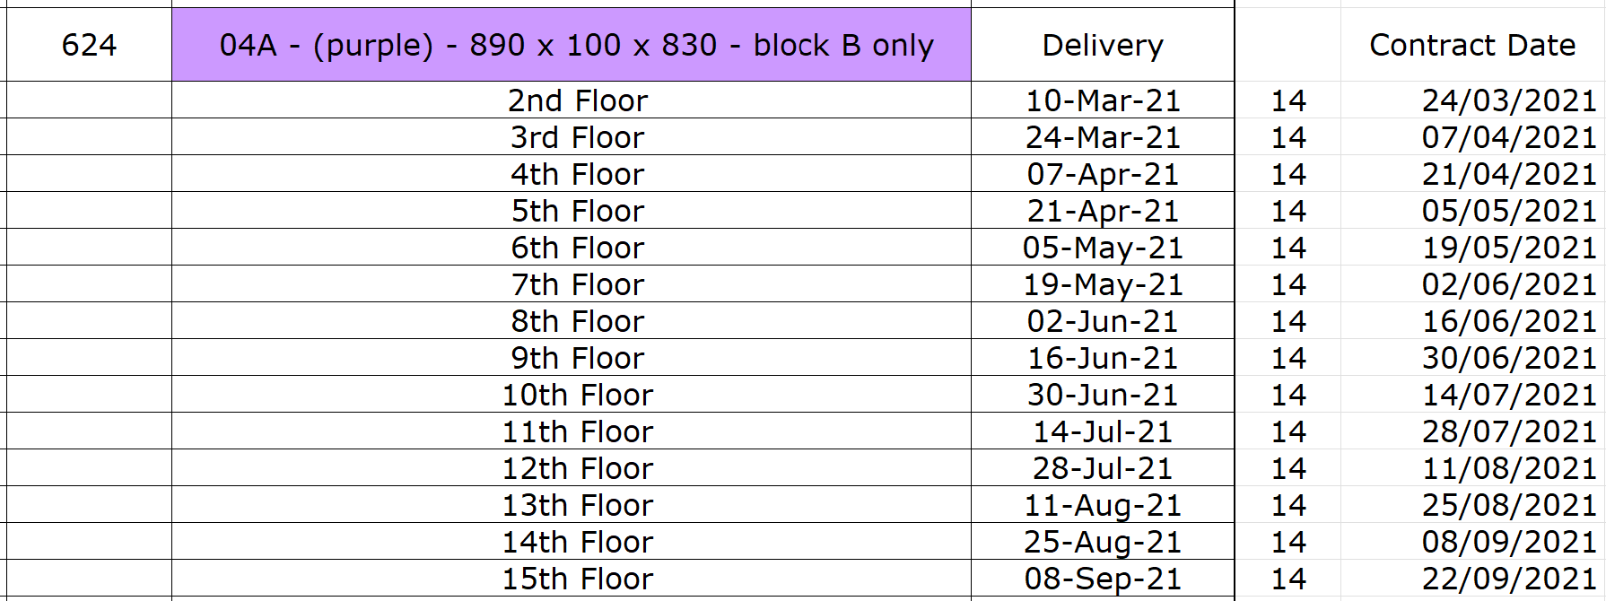
- The ‘Material Requisition Order’, detailed at Appendix X, detailed the quotations as previously provided by Taylor Maxwell and agreed delivery dates for the Vobster stone. These delivery dates were sequenced according to ULS’ delivery programme and had been agreed by Taylor Maxwell.
- Attached to CI06 was a revised set of elevation drawings ‘CI 06 Combined Elevs Vobster Panel Clarifications 2020-09-28’, including a significant number of design parameters and annotations not previously included. The drawings issued under CI 06 significantly altered the design which ULS had priced under CR 07a, as explained further below.
- Examples of the parameters / annotations under CI 06 are as follows:
  - “Vobster stone to panels above brick piers - solid stone to span pier to pier. Joint to be centred on brick piers as marked up in blue. Refer also to detail L(21)_010”
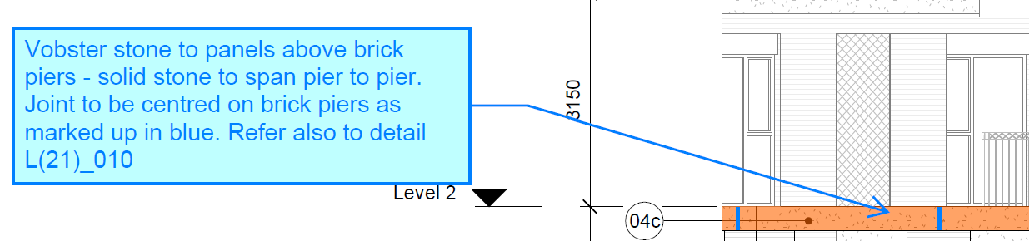
  - “Vobster stone to panels above windows (yellow): Can be a single panel, no joints, max span will be brick to brick, ie. spans over window only. Mark-up above "P" denotes stone and brick in same plane, "R" denotes stone is recessed from brick pier. Refer to contract detail L(21)_009. Continuous orange horizontal banding directly above yellow panels to follow the yellow jointing. CMT to review proposed joint locations post instruction.”
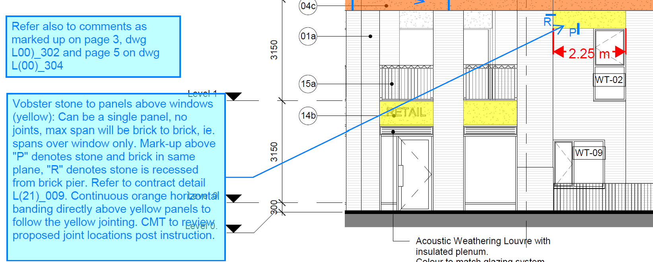
  - “Vobster stone to ground floor panels above windows (yellow): Preference to be a single panel, no joints with potential for stone support to be fixed back to slab edge. See contract detail L(21)_005. If panels need to be reduced, number of panels to be max 3. Note the ground floor is set back from main facade/brick piers, see detail L(21)_005 which also shows a stone soffit. Continuous orange horizontal banding directly above yellow ground floor panels to follow the yellow jointing. CMT to review proposed joint locations post instruction.”
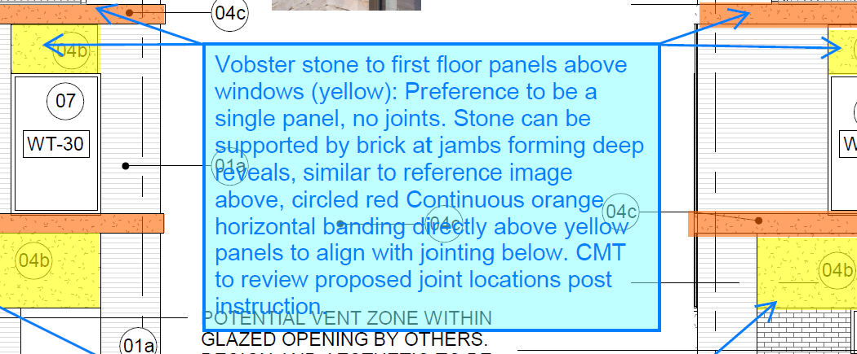
  - “Welbourne signage to be embossed into stone, see contract detail L(21)_007. Preference for stone to be one piece, extent of soffit as shown on detail L(21)_007”
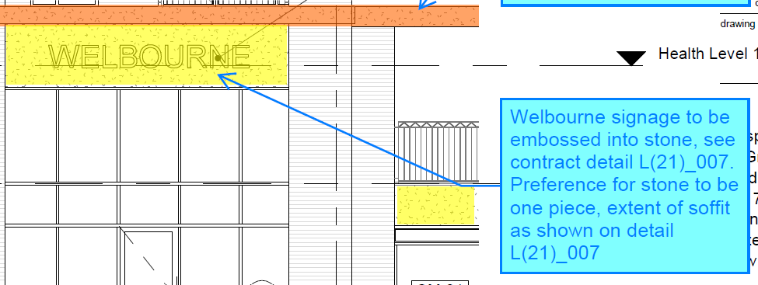
- As instructed under CI 06, ULS issued the revised drawings to Taylor Maxwell to instruct Vobster to proceed with design and manufacture.
- The additional parameters and annotations in the drawings attached to CI 06 required (purely for aesthetic reasons) the stones to be various different sizes, to span between the piers.
- ULS consulted with Taylor Maxwell / Vobster who explained the impact of this change: [which document is this quote taken from?]
“Our original quote was based on the drawings provided that did not show joints. This is usually the case, and we break the stones down to make them manageable and financially viable.
Following on from our quote, we received a set of updated drawings stating where the joints could be and how some units needed to be self-supporting and spanning specific gaps. Drawings C1 06 are a good example of the comments provided to us. We then drew and repriced the stone accordingly, which is where the uplift originated from.”

E. Legal Basis of the Claim
- The change from GRC cladding to Vobster under Change Request 07a and then the change to the parameters / design of the Vobster stone by the revised drawings issued under CI 06 were changes in the Employer’s Requirements which made necessary the alteration or modification of the design of the Works, including:
  - Clause 5.1.1 – the addition, omission or substitution of any work.
  - Clause 5.1.3 – alteration of the kind or standard of any materials or goods to be used in the Works.
- The above Changes constitute Relevant Events and Relevant Matters under clauses 2.26.1 and 4.21.1 respectively.

F. Impact of the Change
(i) Block C
- Following a period of design post instruction of CI 06, Taylor Maxwell provided an updated quotation to the stone at Block C, the first to be manufactured due to the requirement for early fit-out to the Health Centre. The quotation, dated 3 March 2021, was for a revised total of £134,000, an increase of £38,912.07 against the original design from CR07a.
- ULS challenged the cost increases reported by Taylor Maxwell, requesting further justification. A high level summary was initially provided by TM on 3 March 2021, as follows:
“There was 3 separate elements; a band, a spandrel panel and a soffit. These three components are combined in one unit now. This means that there is various increases. The original decorative units are now part of a structural unit needing reinforcing. The units are much larger using specialised moulds and the units now being larger irregular shapes are not possible to deliver in large quantities so transportation costs have increased.”
- ULS requested further substantiation on the changes. Taylor Maxwell provided an example (see Appendix X) and detailed explanation as follows:
“This is 3.2m long and 1m high precast unit with reinforcing (some are 3.5m*1.5m), not two separate units built into brickwork with brickwork support that are just repeating. This is now almost every stone is unique.”
- The above stone, reference ‘C1UB’, is detailed below in the following extract. This extract is a clear example of the bespoke nature of the required stone design. The stones detailed in the lower elevation weigh up to 1,105kg.
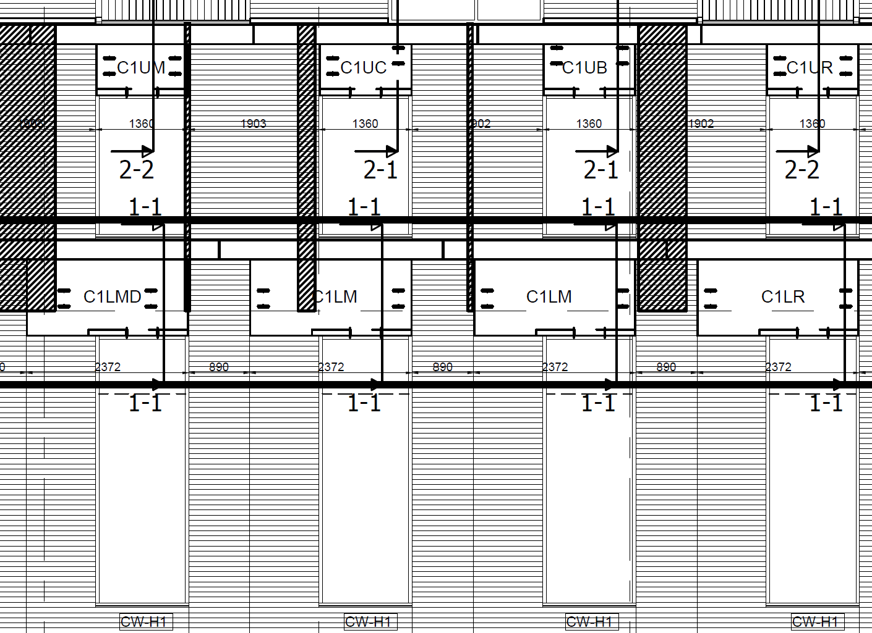
- Further to the above illustrations and explanation, a detailed breakdown was provided by Taylor Maxwell in an excel workbook. This is provided in full at Appendix X.
- Taylor Maxwell provided the following summary:
- Units changed from individual band courses at 1m long to 1.5*3.5m structural units.
- There is a wider band width of 237.5mm opposed to the originally quoted 150mm
- Some units increase in the return from 150mm quoted to 180mm into soffit.
- Haulage now get 4/5 stones on a vehicle. Previously the stone quoted as individual units would have fitted on a pallet or two for the 4/5 stones.
- Mould costs with each stone being unique this requires more moulds and with the moulds being larger and more specialist there is a cost associated with this.
- Structural design from engineer
- Reinforcing
- Cast in Fixings
- Despite not receiving the updated quotation from Taylor Maxwell until March 2021, ULS reported expected cost increases to THDM in the January 2021 Client Contractors Report. The report stated that Taylor Maxwell / Vobster had reported ‘cost growth to maintain the client preferred design option’.
- On 9 March 2021 ULS emailed the EA and CMT providing a further update on the cost increase and delay.
- In summary, the design changes to the Vobster stone for Block C introduced larger, bespoke, structural units [check against Ben Chamberlain report]. This directly increased the costs, complexity, and impacted the programme.
(ii) Block B
- Consistent with the cost increases to Block C, on 3 June 2021 Taylor Maxwell issued their updated quotation for Block B. The quotation was for a total of £294,289.19, an increase of £69,548.26. A full breakdown of the changes are detailed at Appendix X.
- Taylor Maxwell provided the following summary:
  - Band / Spandrel component combined forming large format components
  - Fixing / Lifting hardware added.
  - Additional reinforcement due to size / shape of components
  - Decorative Panel widths increased, increasing total meterage by 30m
  - A large number of these decorative panels were revised to L-Shape
  - Soffits width Increased from 500 Wide to 685
  - Depth of soffits Increased from 75mm to 100mm
  - Fixing channels add to two sides of soffits
  - Delivery quantity increase due to size of units.
  - Band course lifting hardware added
  - Additional reinforcement due longer lengths on Band Course
- Examples of the variety and complexity of the stone required on Block B and illustrative of the changes identified above, see below extract from the Vobster stone Block B drawings:
  - The below stone is from elevation 3, level 2 of Block B, at 3.7m in length and weighing circa. 1 tonne. Further details such as the fixing channels, reinforcement and lifting eyes are detailed.
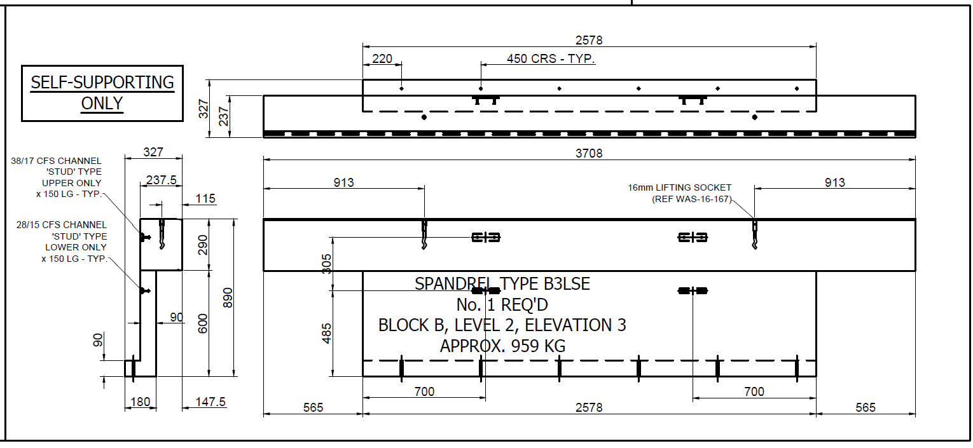
  - Notably the shape of the below stone is entirely different to the above with the band and spandrel matching in length to the left of the unit. This demonstrates the variety of the units across the block.
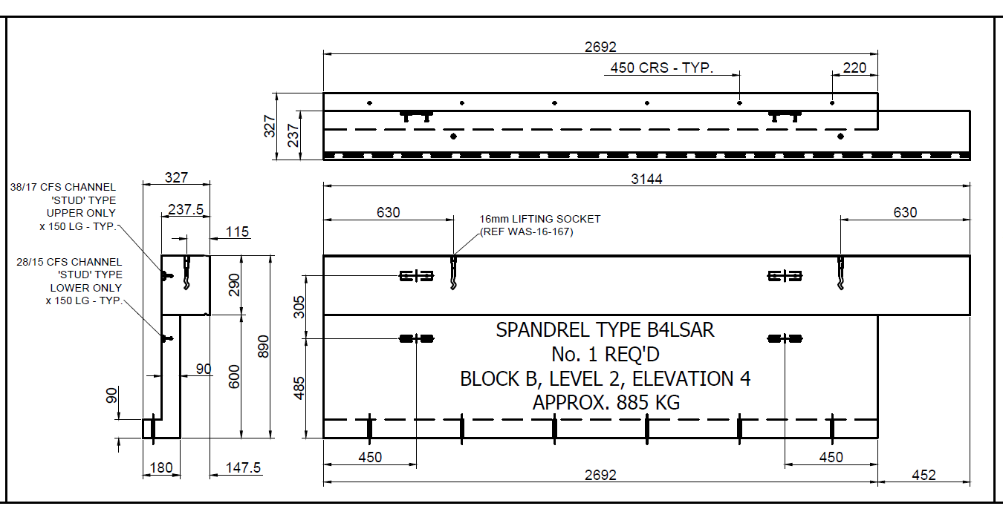
- Further to the above illustrations, the variety in feature panels is evident in the below drawings, showing four different sizes of panels required:
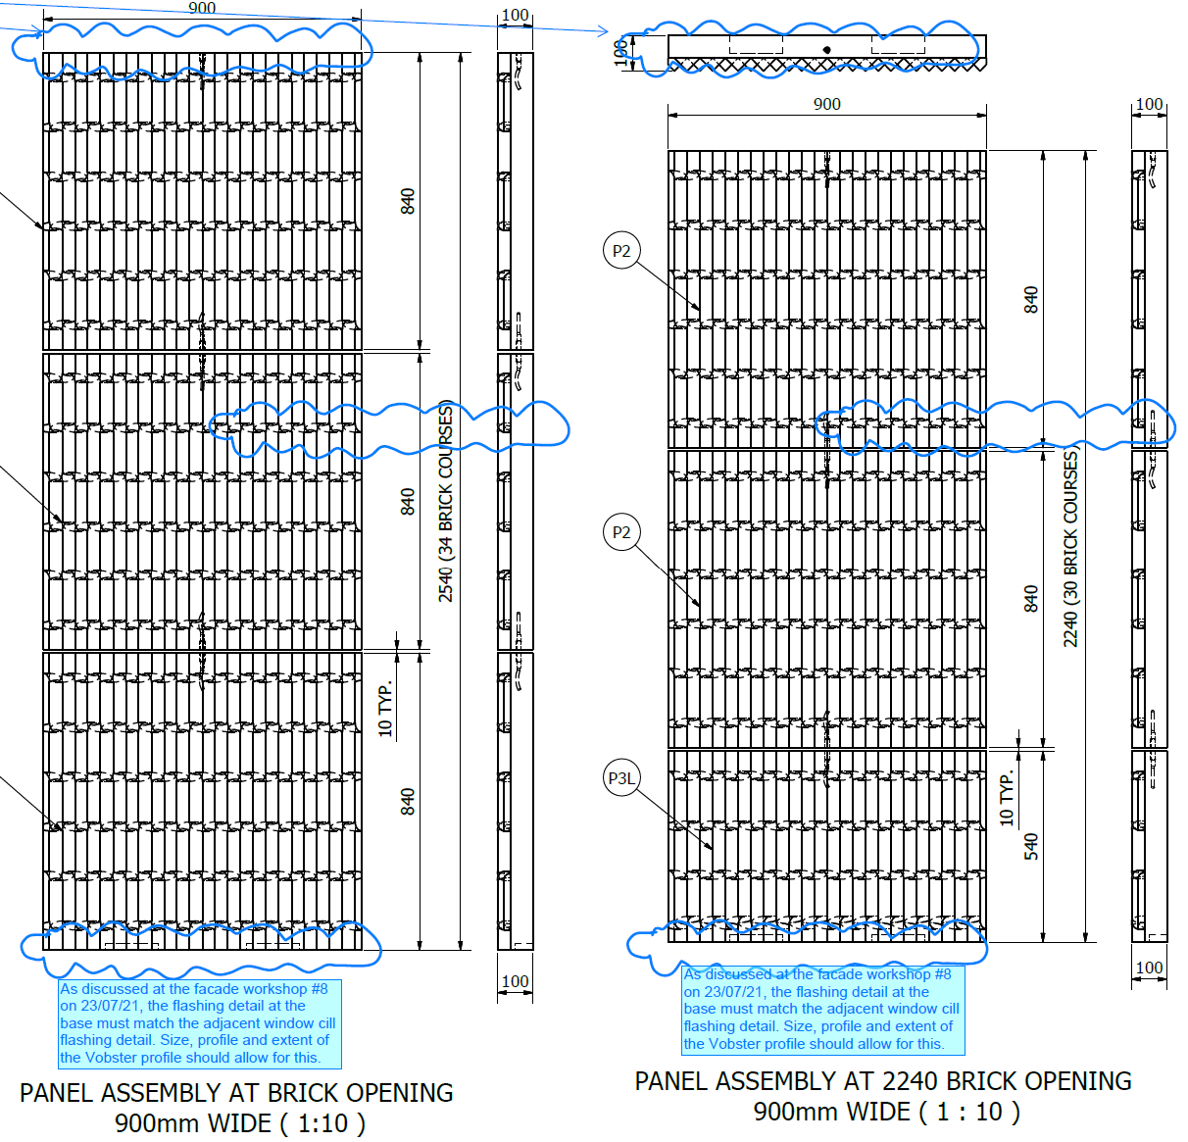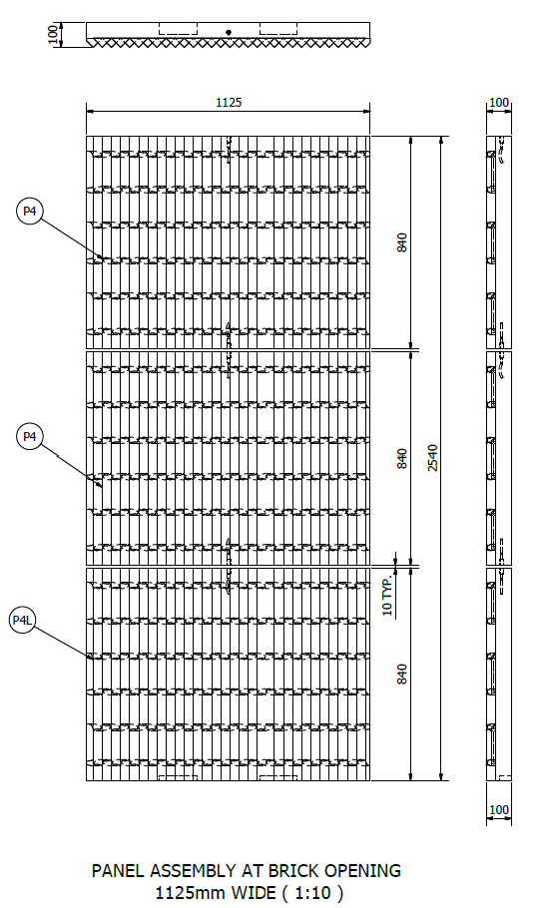
- Following the design changes detailed above, ULS reported costs increases in the June 2021 Client Contractor Report, the same month provided by Taylor Maxwell, as follows:
“Vobster – cost have now been received for block C & B. The revised cost increase is now £110k. Have draft cost document to send to client and will now include this recovery within the valuations going forward.”
- As a further Change, [Please confirm this was a further change?] in November 2021 the EA advised that the wording on the front of the Health Centre was to be changed to ‘Walter Tull House’. The level of bespoke detailing is clearly apparent in the below drawing extract:
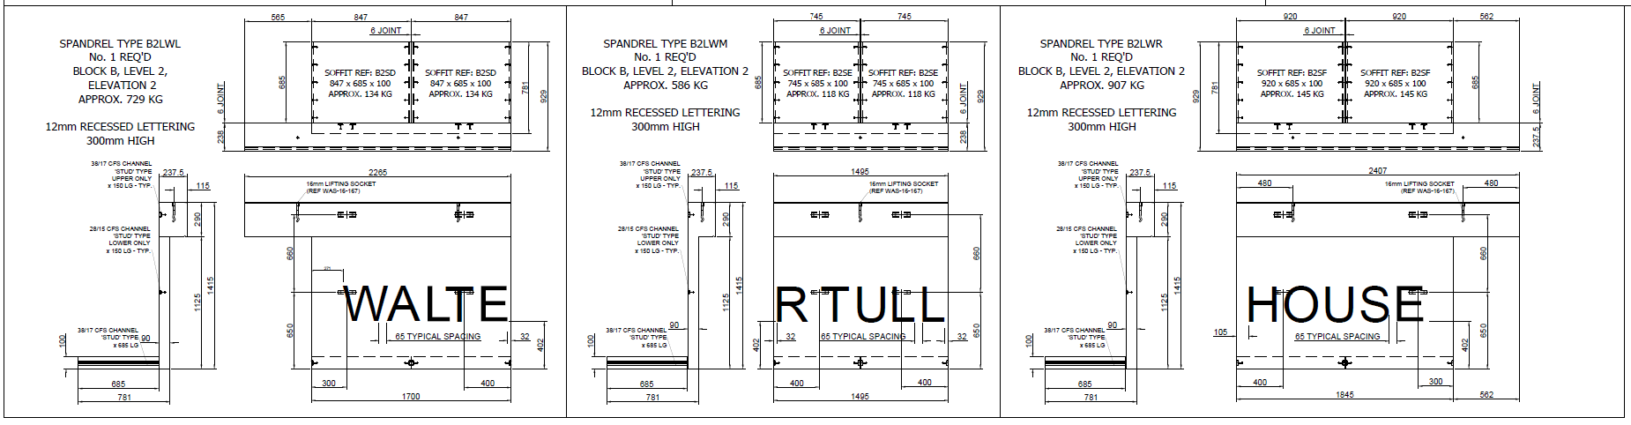
- Consistent with the changes to Block C, the design modifications to the Vobster stone for Block B introduced larger, bespoke, and structurally complex units. This significantly impacted the cost and programme.
(iii) Block A
- On 4 March 2022, ULS received the updated quotation from Taylor Maxwell for Block A. The value was £41,449.49, an increase of £23,265.51. A full breakdown of the changes are detailed at Appendix X.
- Taylor Maxwell provided the following summary:
- “Originally there was only one section (now there are two), and both sections have increased from 137x290 to 137x365 and 237x365 respectively from the original quote.
- New band moulds for the 137x365 will be required, originally costed to come from the same moulds as used on the other blocks.
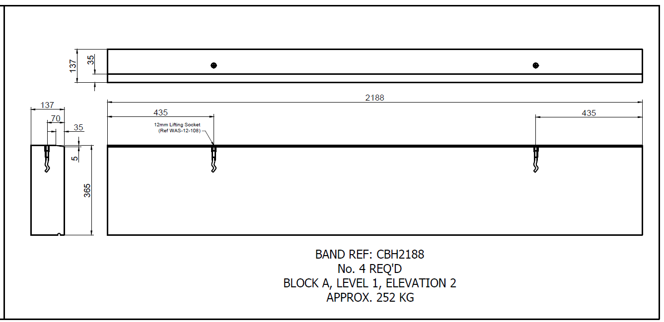
- New band mould for the 237x365 will be required, originally costed to come from the same moulds as used on the other blocks.
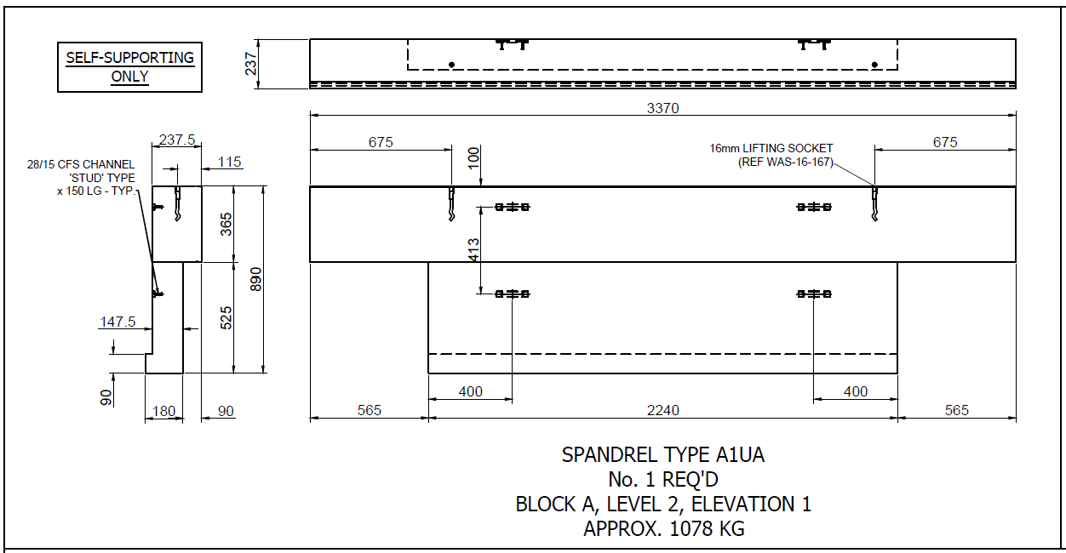
- Increase in material of 4 tons (including the band units now incorporated into the spandrel panels) due to the larger sections.
- New spandrel moulds will be required to accommodate the larger band sections, originally costed to come from the same moulds as used on the other blocks.”

- As referenced above, the band / spandrel component combined from two smaller separate stone to form single large-format components. This required fixing and lifting hardware and additional reinforcement due to size and shape of the components. The size and irregularity of the stones are clearly demonstrated in the below extract:
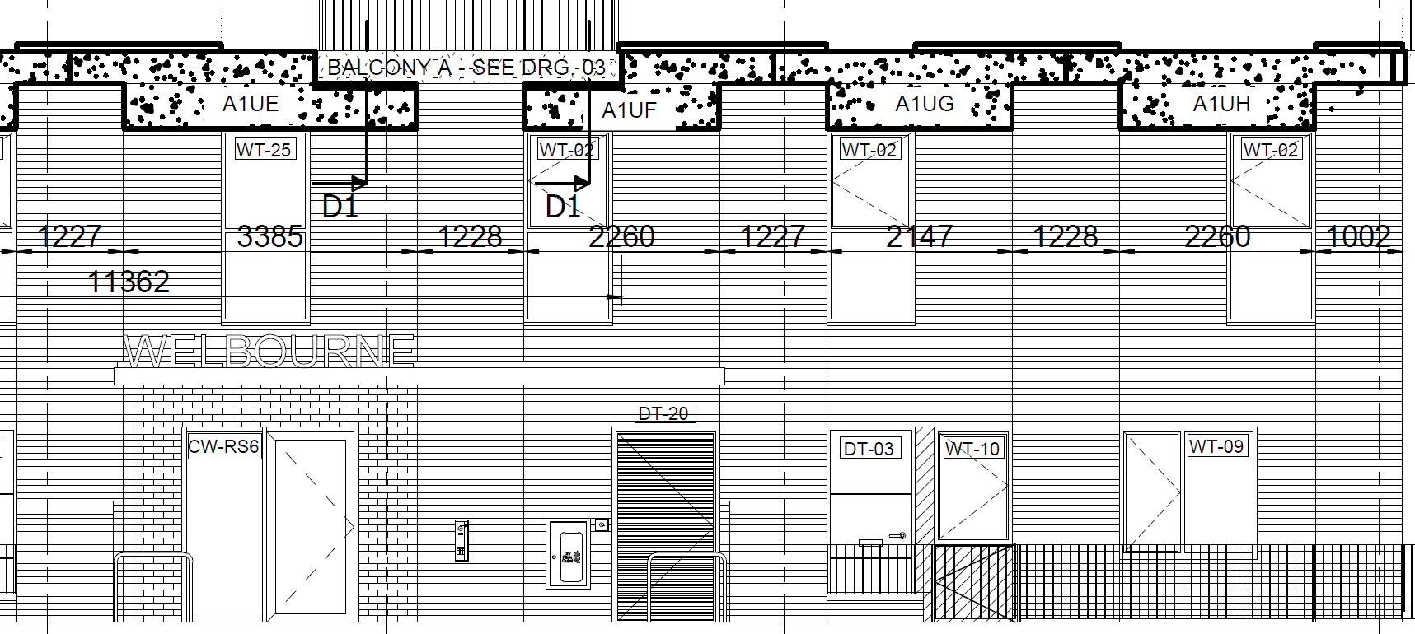
- As a result of the substantial design changes instructed under CI 06, there were 20 unique stones required on Block A, all requiring bespoke specialised moulds. The stones weighed up to 1.5 tonne per unit, as detailed below:
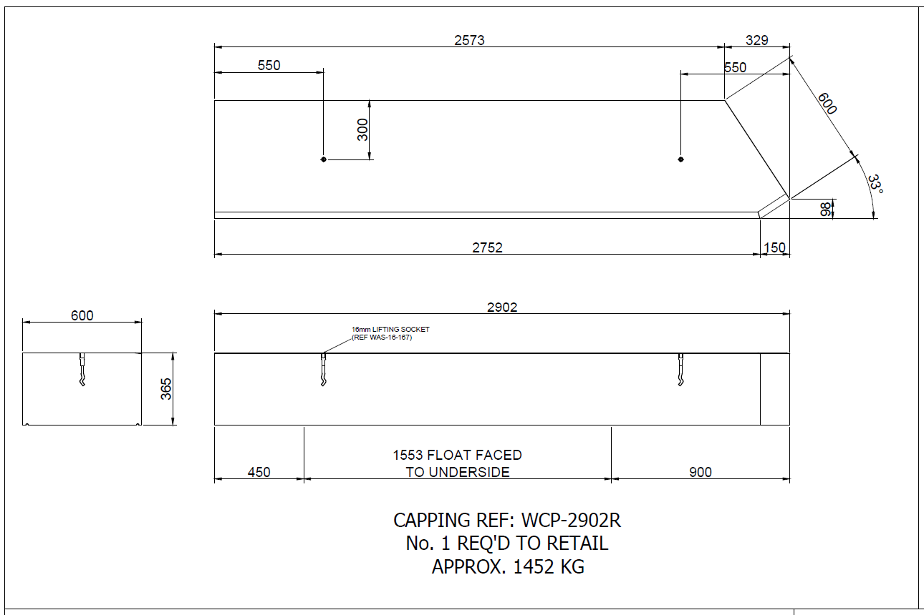
- COST INCREASE REPORTING TBC, AS PER BLOCKS C & B ABOVE [We just need to refer to the first cost increase reporting].
[TBC if we keep the above section/ if we can develop it. We are relying on Vobster as a delay into 2023. So we have an impact section we probably need to continue the chronology/explanation beyond that set out above, or have dealt with it elsewhere in the FA and refer to it]
(iv) Summary
- [We should provide a summary of the total direct cost increase, the total delay and the total L&E which we say was caused by the Vobster If possible separating between prolongation, thickening, and subcontractor claims]

United Living (South) Limited
January 2025

Page 5,109 of 8,281
R190056 - Welbourne, Tottenham Hale
INSERT EMAIL REFERENCE
THW Welbourne - GRC saving
RE_ THW Welbourne - GRC alternative cost
EMAIL REFERENCE
Block C Cost Difference – extracted from RE: Taylor Maxwell Quote: QLH/004401/001 - UNITED LIVING SITE, TOTTENHAM HALE, CHESNUT ROAD, WELBOURNE, N17 9EU
FW: Stone - Welbourne
Welbourne Tottenham Hale Client Contractors Report Meeting Thursday 21st January 2021
QLH_004841_001 - UNITED0052
FW_ Stone - Welbourne
Increase to Block C £38,912.07 + increase to Block B £69,548.26 = £108,460.33
FW_ Stone - Welbourne
Extract from drawing X, added by ULS for illustration.
Extract from drawing X, added by ULS for illustration.
Extract from drawing X

